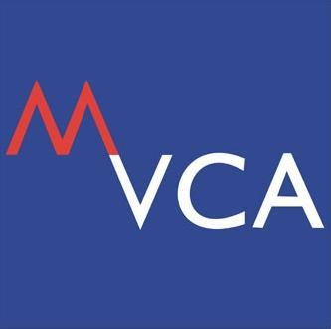

BRUNCH TALK & NETWORKING SESSION

presented by

AON

25 February 2014 (Tuesday)
10.00am
KLGCC

REGISTRATION FORM

Kindly PRINT or TYPE clearly the following information:

Organisation
1st Participant
Name |  | Designation
Telephone |  | Email
2nd Participant
Name |  | Designation
Telephone |  | Email

3rd Participant
Name |  | Designation
Telephone |  | Email

NOTE:
For more information please kindly call us at 03-2300 6550 and fax this form to 03-6206 2484.

