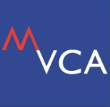

VC2E Roadshow 2014

WHAT IS VENTURE CAPITAL &
OTHER ALTERNATIVES OF BUSINESS FUNDINGS

Every year, the Malaysian Venture Capital and Private Equity Association (MVCA) holds a special programme for investors to meet the entrepreneurs.

This event, known as VC2E has been conducted since 2008 and is one of the best platforms for entrepreneurs to meet the venture capitalists and other investors, and seek answers to their many enquiries on venture capital funding.

Each year, the event will feature a line-up of speakers from venture capital companies in Malaysia talking about their investment criteria and what they look for in entrepreneurs and businesses that they want to invest in.

This year, we are taking the event to Johor, Penang and Pahang to meet up more SMEs and inform them of the funding opportunities that they might not even know available.

Benefits of VC2E
For VCs and other investors, this event can help them to;
- Elevate their presence towards the entrepreneurs community
- Better inform the entrepreneurs of their investment interest, stage and size
- Receive improved and better quality of business plans submissions

As for entrepreneurs, VC2E can assist them to;
- Get to know the investors and how to approach them
- Better understand the alternatives of business funding
- Be prepared in presenting feasible and convincing business plans for the investors

Every year, in Kuala Lumpur the event gathers between 70 to 100 participants. The crowd range from college and university students, researchers, start-up companies, growing companies and even mature companies.

Everyone is welcomed to attend the VC2E. Do not miss this opportunity to be heard and be known.

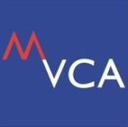

VC2E Roadshow 2014
30 October 2014 (Thursday)
MSC Cyberport, Johor Bahru, Johor

WHAT IS VENTURE CAPITAL &
OTHER ALTERNATIVES OF BUSINESS FUNDINGS

EVENT PROGRAM

9.00am | Registration
9.30am | Welcome Remark by MVCA Chairman
9.35am | What is the difference between VC, PE, Angel Investors and other source of financing?
10.30am | What Investors Look for When Investing?
11.30am | Brunch & Networking
12.30pm  2.30pm | One-to-One Session  End of Program

Platinum Sponsor

Silver Sponsor
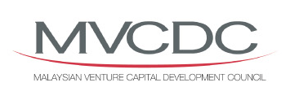

Venue Sponsor

Register NOW,
Seats are limited!

REGISTRATION FORM

VC2E Roadshow 2014
30 October 2014 (Thursday)
MSC Cyberport, Johor Bahru, Johor

Company
Nature of Business
1st Participant
Name |  |  |  | Designation
Email |  |  |  | Telephone
Booking for One-to-One Session?* |  |  |  | YES |  | NO

2nd Participant
Name |  |  | Designation
Email |  |  | Telephone
Booking for One-to-One Session?* |  |  | YES |  | NO

Please email or fax back by 27 October 2014 to info@mvca.org.my or 03-2300 6550

NOTES
- Seats and Booking for One-to-One Sessions are limited. Organisers reserve the rights to decline any booking or registration made through this form.
- If you wish to send more than three participants please kindly make a copy of this form and fax back or email back to us at 03-6206 2484 or info@mvca.org.my.
- Based on the Personal Data Protection Act, MVCA will not disclose this information to any third party and the information will solely be used for MVCA events only.

